FuzeBox AEOS — Full Architecture Document

Technical Specification with Visual System Designs
April 2026 · FuzeBox.AI · Confidential
Companion to: FuzeBox AEOS White Paper · One-Week Demonstration Specification
Audience: Engineering build partners · Technical leadership · Strategic technology partners · Prospective integration teams at Anthropic, OpenAI, Salesforce, Cloudflare, Google, Uniphore, and rPotential

Introduction
This document is the full architectural specification of the FuzeBox Agentic Enterprise Operating System. It describes every major component — the twelve layers, the eight microservices, the canonical data schema, the six runtime vendor integrations, the rPotential closed loop, the per-Boundary governance enforcement, the Dynamic Instruction Runtime, and the Execution Economic Ledger — at the level of detail required to build, integrate with, or evaluate the system.
The architecture is not speculative. The GSTI algorithm is implemented and producing scores on real enterprise processes. The Coordination Tax calculator is implemented and consuming real process event streams. The Universal Execution Function is specified in full and ready for production build. The five patent families that protect the combined architecture are in filing, four of them jointly with rPotential. What remains is the coordinated production engineering effort to bring the full system to the scale and polish the category demands. This document is the blueprint for that effort.
Every diagram in this document is drawn from an in-depth system design exercise. The diagrams are not decorative. They are the visual expression of architectural decisions that have been tested against the competitive landscape, the regulatory landscape, the commercial landscape, and the engineering feasibility of each component. Read them alongside the text; each figure anchors a specific architectural point that the text elaborates.

Part I — System Overview

The Four Zones and Twelve Layers
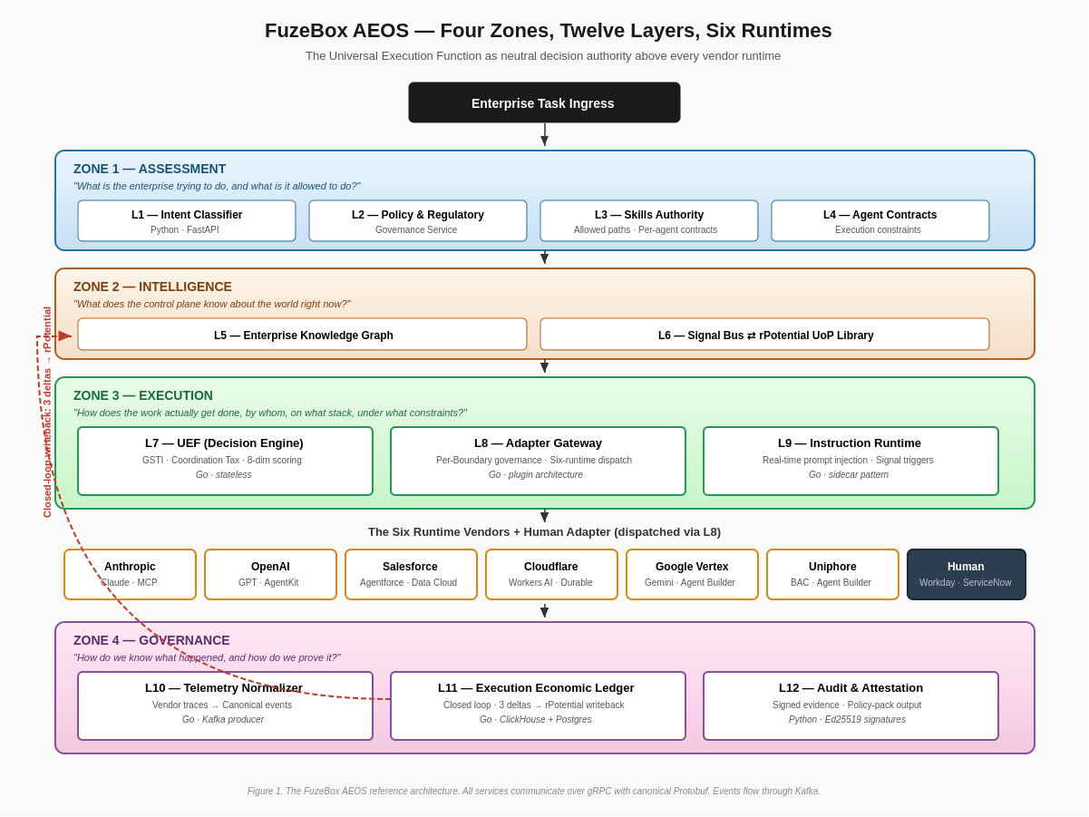
Figure 1 — FuzeBox AEOS: four zones, twelve layers, six runtimes
FuzeBox AEOS organizes enterprise AI decisioning into four operational zones spanning twelve layers. Every task that flows through the system traverses all four zones in sequence, producing at the end a completed execution with a cryptographically signed audit artifact and a closed-loop writeback to the workforce intelligence graph.
The Assessment Zone spans Layers 1 through 4. Its job is to translate the enterprise task into a fully characterized work unit that the rest of the system can reason about. The Intent Classifier at Layer 1 receives the raw task submission and produces a Task object enriched with task type, complexity estimate, risk level, regulatory class, strategic significance, and workforce impact scope. The Governance Service at Layer 2 loads every policy pack applicable to the tenant, the jurisdiction, and the task type, and returns a consolidated GovernanceRequirement that specifies audit obligations, human signoff requirements, data residency rules, retention periods, explainability mandates, and cross-border transfer authorizations. The Skills Authority at Layer 3 resolves which Skill the task requires and returns the allowed execution paths and the per-agent Contracts that constrain what each candidate path may do. Layer 4 maintains those Contracts. This zone answers what the enterprise is trying to do and what it is allowed to do, in terms the rest of the system can process deterministically.
The Intelligence Zone spans Layers 5 and 6. The Enterprise Knowledge Graph at Layer 5 holds organizational context — the tenant’s org structure, prior decisions on similar tasks, the strategic capability map that identifies which skills are mission-critical, and the workforce composition. The Signal Bus at Layer 6 is the bidirectional bridge to rPotential. It streams live WorkforceSignals into FuzeBox at the moment of every decision and forwards execution-outcome deltas back to rPotential’s UoP library as every execution completes. This zone answers what the control plane knows about the world at the exact moment of decision.
The Execution Zone spans Layers 7 through 9 and contains the core intellectual property of the system. The Universal Execution Function at Layer 7 is the callable decision authority — the service that receives the Task, the Skill, the Contracts, the GovernanceRequirement, and the WorkforceSignals, scores every candidate execution path across eight orthogonal dimensions, and returns the selected ScoredPath with full structured justification. The Adapter Gateway at Layer 8 receives the approved decision, validates it against the per-Boundary rules for the tenant-runtime pair, applies jurisdiction-specific transformations, and dispatches to the selected runtime vendor or the Human Adapter. The Dynamic Instruction Runtime at Layer 9 is the sidecar service that injects real-time prompt modifications, tool constraints, and policy updates into in-flight executions as signals change — the capability that makes FuzeBox a control system rather than a routing layer.
The Governance Zone spans Layers 10 through 12. The Telemetry Normalizer at Layer 10 converts vendor-native execution traces — which differ in structure between Anthropic, OpenAI, Salesforce, Cloudflare, Google, and Uniphore — into a canonical event schema that the Ledger can process uniformly. The Execution Economic Ledger at Layer 11 records every outcome, computes the three deltas that close the loop back to rPotential, exposes the seven derived metrics that drive the board-level Enterprise Autonomy Index, and archives immutably for audit. The Audit and Attestation service at Layer 12 produces cryptographically signed evidence bundles formatted per policy pack, delivered to the tenant’s evidence store for regulatory inspection.
This four-zone structure is not arbitrary. Each zone answers one of the four questions that every enterprise AI deployment must answer to be operationally defensible: what are we trying to do and what are we allowed to do (Assessment), what do we know about the world (Intelligence), how do we actually execute (Execution), how do we prove what happened (Governance). Runtime vendors build pieces of each zone for their own runtimes. FuzeBox is the only system that integrates all four zones across every runtime, with the workforce intelligence graph as a first-class data input and the audit trail as a first-class product output.

Part II — The Request Flow

End-to-End Trace of a Single Task
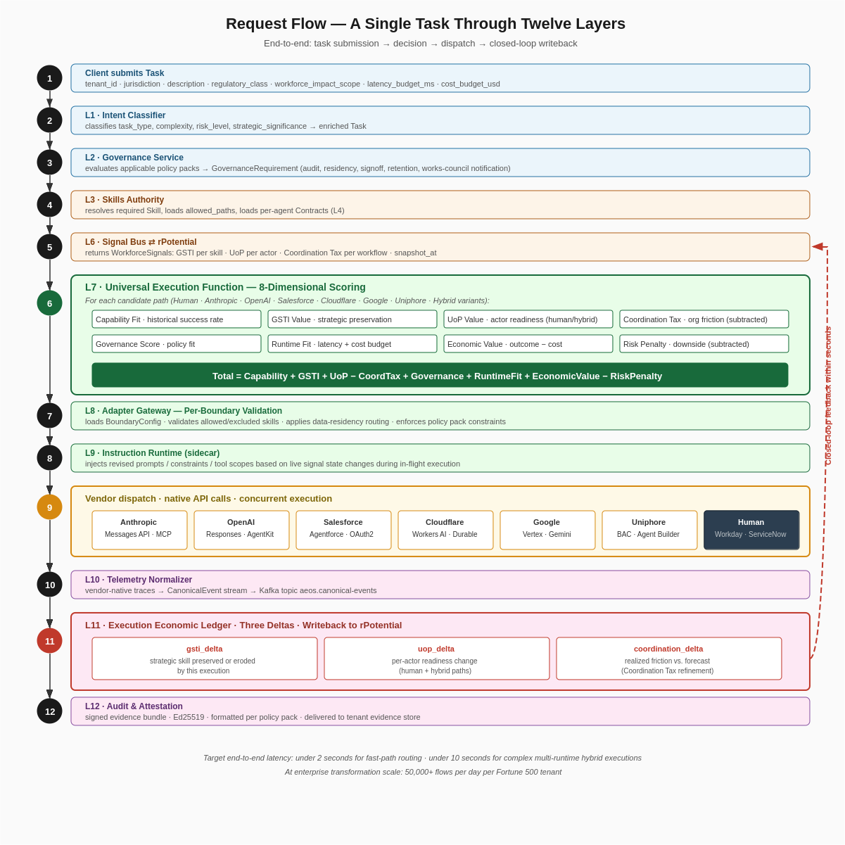
Figure 2 — Request flow: a single task through twelve layers
Understanding AEOS requires tracing a single task through every layer. The flow shown in Figure 2 is the canonical path. Every enterprise task follows this sequence; the scale varies (a Fortune 500 tenant processes tens of thousands per day, a smaller deployment processes hundreds), but the path is identical for each.
The task enters at step 1 with the enterprise client submitting a Task payload — tenant identifier, jurisdiction, task description, regulatory class, workforce impact scope, latency budget, cost budget, and metadata. At step 2 the Intent Classifier reads the payload and classifies what kind of task it is: diagnostic, analysis, advisory, synthesis, transaction, orchestration, planning, transformation. The classifier also evaluates complexity and strategic significance. The enriched Task is now ready for governance evaluation.
Step 3 takes the enriched Task to the Governance Service, which loads every policy pack applicable to the tenant-jurisdiction pair. The pack list is composed at evaluation time: for a Germany-domiciled tenant executing a regulatory analysis task, the packs might include EU AI Act Article 14 high-risk, GDPR, German works-council notification rules, and the tenant’s SOC 2 profile. The Governance Service merges the packs into a single GovernanceRequirement — what audit must be produced, how long traces must be retained, whether human signoff is mandatory, whether explainability must be provided, where data can reside, whether cross-border transfer is permitted. This is the definitive contract for how the task must be governed; the rest of the system obeys it.
Step 4 calls the Skills Authority. The Skills Authority resolves which Skill the task requires — regulatory analysis, in this example — and returns the full Skill record, which includes the allowed execution paths (perhaps HUMAN, ANTHROPIC_HUMAN_HYBRID, GOOGLE_HUMAN_HYBRID, but specifically not ANTHROPIC alone or OPENAI alone because this Skill is governance-tagged as strategic and the drift risk is elevated), the per-path performance history, the strategic weight, and the governance tags. The Authority also surfaces the per-agent Contract data from Layer 4 that constrains what each candidate path is allowed to do in terms of tool access, data scope, and decision authority.
Step 5 calls the Signal Bus, which returns the current WorkforceSignals snapshot streamed live from rPotential. The snapshot contains GSTI per skill (the strategic weight calibrated by rPotential’s UoP library), skill_drift_risk per skill (which skills are drifting out of the workforce), UoP per actor (the readiness, fatigue, and capacity of every human actor in the pool relevant to this Skill), and Coordination Tax per workflow (the measured organizational friction on the workflow the task belongs to). The snapshot is typically 50–200ms old because it is continuously refreshed.
Step 6 is the UEF decision. The UEF enumerates every candidate execution path that the Skill permits — in a Fortune 500 deployment with six runtime vendors, a human adapter, and hybrid combinations, this can be 14 to 21 candidate paths per task, though governance constraints typically filter to 4 to 8 eligible paths. For each eligible path the UEF computes eight sub-scores: Capability Fit (historical success rate weighted by recency), GSTI Value (strategic preservation scoring against the current drift risk), UoP Value (best-fit actor selection for human and hybrid paths, baseline for agent-only paths), Coordination Tax (organizational friction subtracted), Governance Score (policy-pack compliance fit), Runtime Fit (latency and cost budget), Economic Value (expected outcome minus cost), and Risk Penalty (downside exposure). The composer sums the positive dimensions and subtracts the negative ones, ranks the paths descending, and returns the highest-scoring path with structured justification including the top three alternates for audit.
Step 7 takes the ScoredPath to the Adapter Gateway. The Gateway loads the BoundaryConfig for the tenant-runtime pair — if the UEF selected a hybrid of Anthropic plus Human, there are two Boundaries to consider: Anthropic under the tenant’s EU Boundary, and Human under the tenant’s workforce management integration. The Boundary tells the Gateway exactly which endpoint to route to (for Anthropic under EU Boundary, that is an EU-resident Claude deployment), which system prompts and constraints to inject, what data to redact, and what evidence to capture.
Step 8 brings in the Instruction Runtime as a sidecar. Between the approved decision and the actual dispatch, the Runtime evaluates whether any triggers fire based on current signal state. If, for example, the task is tagged safety_relevant and the Skill’s GSTI has moved below a tenant-configured threshold since the last time this tenant executed this Skill, the Runtime injects a tightening constraint — perhaps increasing the human review depth or adding an explainability requirement to the Claude system prompt. Injections are captured in the audit record so that every modification to an execution is traceable.
Step 9 is the actual vendor dispatch. For a hybrid Anthropic + Human path, the Gateway fires the Anthropic call using the Messages API with the Boundary-specific system prompt and the Instruction Runtime’s injections, and concurrently queues the Human Adapter task to the appropriate compliance lead. Both executions run in parallel. The Gateway composes the responses when both complete. For single-runtime paths, only one dispatch occurs. For multi-vendor agent chains — a decomposed workflow where the UEF selects, say, Anthropic for reasoning plus Google Vertex for multi-modal analysis plus OpenAI for large-volume document processing — the Gateway orchestrates all of them in the correct sequence.
Step 10 captures the raw vendor traces as executions complete. The Telemetry Normalizer transforms each vendor’s native trace format — Anthropic’s streaming event log, OpenAI’s Responses API trace, Salesforce’s Agent platform log, Cloudflare’s Workers AI telemetry, Google Vertex’s structured trace, Uniphore’s workflow event stream — into a canonical CanonicalEvent schema. The normalized events stream to a Kafka topic for durable processing.
Step 11 is where the loop closes. The Ledger Service consumes the canonical event stream, composes the LedgerRow for this execution (including the realized cost, latency, outcome value, and risk exposure), and computes the three deltas. The gsti_delta measures how this execution changed the strategic weight of the Skill — positive for successful strategic-skill preservation, negative for erosion. The uop_delta measures the per-actor readiness change for every human actor involved — positive for successful strategic-skill exercise, negative for fatigue accumulation or skill bypass. The coordination_delta measures how the realized friction compared to the Coordination Tax forecast — negative when the hybrid or orchestration path ran cleaner than predicted, positive when it ran messier. The LedgerRow writes immutably to ClickHouse with a PostgreSQL mirror for the most recent seven days. The deltas write back to the Signal Bus, which forwards them to rPotential’s UoP library via the joint-IP writeback contract. rPotential acknowledges within 500ms at P95; its workforce graph updates. The next UEF decision in this tenant reads the updated state.
Step 12 is the final governance artifact. The Governance Service composes a signed evidence bundle for the execution — the Task, the ScoredPath with justification, the BoundaryConfig applied, the Instruction Runtime injections, the LedgerRow, and the policy-pack-specific evidence format. The bundle is signed with Ed25519 and delivered to the tenant’s evidence store. For an EU AI Act Article 14 task, the bundle is in Article 14 evidence format. For a SOC 2 task, it is in SOC 2 evidence format. For a HIPAA task, it is in HIPAA evidence format. Every execution produces an artifact that can be handed to a regulator, a works council, an internal auditor, or an affected employee.
This entire flow — steps 1 through 12 — completes in under 2 seconds for fast-path routing decisions and in under 10 seconds for complex multi-runtime hybrid executions. At enterprise transformation scale a single Fortune 500 tenant produces 50,000+ of these flows per day. The architecture is designed from the ground up to scale to that volume.

Part III — The Six Runtime Integrations

Adapters as Plugins Behind a Common Interface
The Adapter Gateway treats every runtime vendor as a plugin behind a common Go interface. This design choice is load-bearing: it is what makes FuzeBox neutral. No runtime is privileged in the code. Adding a seventh runtime or swapping implementations of existing runtimes is a plugin operation, not a refactor of the control plane.
type Adapter interface {
Name() ExecutionPath
Dispatch(ctx context.Context, req DispatchRequest) (DispatchResponse, error)
HealthCheck(ctx context.Context) error
CostEstimate(ctx context.Context, req DispatchRequest) (CostEstimate, error)
Capabilities() AdapterCapabilities
}
Each adapter lives in its own Go package under adapters/{vendor}/. Each has a corresponding mock under mocks/{vendor}/ that returns deterministic responses for CI and for development without live credentials. Each has its own test suite covering the full Adapter interface contract.
Anthropic. The adapter integrates with Claude models via the official Anthropic Go SDK. The primary pathway is the Messages API for standard chat-completion-style execution; the secondary pathway is MCP for tool-integrated execution where Claude calls FuzeBox-defined tools. The adapter supports streaming, structured output via tool definitions, and the Claude Code SDK for multi-step reasoning workflows that span multiple turns. Rate limiting is handled with exponential backoff respecting Anthropic’s usage-tier quotas. Cost estimation uses the published Anthropic pricing table, computing input-token and output-token cost per model. The adapter is production-ready against Anthropic’s Enterprise tier. Trust-tier default for boundary configuration is HIGH; enterprise tenants with Anthropic enterprise agreements can be elevated to HIGHEST. Typical latency observed is 400ms-2s depending on model and streaming configuration.
OpenAI. The adapter integrates with GPT models via the Responses API and AgentKit. The primary pathway is the Responses API for reasoning-heavy execution; AgentKit is used for structured workflow execution with predefined function calling. The adapter also supports the Assistants API for stateful multi-turn execution where conversation context is maintained server-side. Rate limiting respects OpenAI’s token-per-minute quotas and handles 429 responses with exponential backoff. Cost estimation uses published OpenAI pricing. Trust-tier default is MEDIUM-HIGH; enterprise contract tier influences the default. Typical latency is 500ms-3s.
Salesforce Agentforce. The adapter integrates via OAuth2, the Agent API, and Data Cloud connectivity. This adapter is chosen when the source-of-truth enterprise data lives in Salesforce — customer records, workforce records for Workday-integrated tenants, opportunity pipeline, service data. The adapter authenticates via the Salesforce OAuth flow, routes to the tenant’s Agentforce endpoint, and composes Data Cloud queries as part of the execution context. Cost estimation uses Einstein Agent consumption pricing. Trust tier varies significantly by customer’s Salesforce environment maturity and Data Cloud configuration. The adapter handles Salesforce’s session management and concurrent request limits.
Cloudflare. Two distinct modes. The Workers AI mode targets low-latency edge inference — used for high-volume classification tasks, routing pre-checks, and high-velocity decisions where the 50ms edge advantage compounds across millions of calls. The Project Think mode (or its successor durable-agent offering) targets long-running workflows that persist across sessions, hours, or days via Durable Objects. A single task may invoke Workers AI for an immediate sub-decision and Project Think for a parallel long-running analysis. Cost estimation uses Cloudflare’s Workers AI per-neuron pricing for edge execution and Durable Objects pricing for persistent execution. Trust tier varies by deployment configuration.
Google Vertex AI. The adapter integrates with Gemini models via the Vertex AI API, plus Agent Builder for multi-step agents and Agent Garden for pre-built domain agents. Gemini’s multi-modal capability — document plus image plus video inputs — is the primary reason the UEF selects this runtime for many enterprise tasks. The adapter also integrates with Google Workspace and Google Search grounding where those data sources add material value. Authentication uses service account JSON. Cost estimation uses Vertex AI pricing. Trust tier varies by tenant’s Google Cloud agreement maturity and data-residency configuration.
Uniphore. The adapter integrates with Uniphore’s Business AI Cloud via its MCP-compatible endpoint and Agent Builder. The Uniphore adapter is the narrowest of the six by design: Uniphore’s sweet spot is voice-first contact center workflows and CX domain specialization, and the UEF selects Uniphore for tasks where that specialization matches. Uniphore’s own public claim to be a centralized MCP orchestrator is architecturally subordinate inside a FuzeBox deployment — Uniphore is governed as one runtime among six, not as the governance authority. The adapter handles Uniphore’s authentication, workflow dispatch, and event streaming.
The Human Adapter. Not a vendor runtime, but the seventh candidate path. The Human Adapter integrates with enterprise workforce management systems — Workday, SAP SuccessFactors, ServiceNow, bespoke HRIS platforms, or the tenant’s own internal task management system — and routes tasks to the appropriate human actor based on skills authorization, availability, jurisdiction, and organizational reporting lines. The adapter supports blind reviews (where multiple humans evaluate the same task without visibility into each other’s answers), parallel human evaluations (for statistical validation), and multi-level approval chains (escalating through levels of authority). Every hybrid execution path includes the Human Adapter alongside one or more vendor runtimes. Trust tier is HIGHEST by default.

Vendor Capabilities Table
Runtime | Primary Use | Typical Latency | Cost Profile | Trust Default | Hybrid Compatible
Anthropic | Reasoning, strategic synthesis, hybrid with human | 400ms–2s | Moderate-high | HIGH | Yes
OpenAI | Large-volume, conversational, structured workflows | 500ms–3s | Moderate | MEDIUM-HIGH | Yes
Salesforce | Data-gravity tasks, CRM-adjacent, workforce-adjacent | 800ms–4s | Varies by tier | Varies | Yes
Cloudflare | Edge inference, high-volume classification, durable agents | 50ms–10s+ | Low | Varies | Yes
Google Vertex | Multi-modal, Workspace-integrated, grounded | 600ms–3s | Moderate | Varies | Yes
Uniphore | Voice-first CX, contact center automation | 1s–5s | Moderate | MEDIUM | Yes
Human | Strategic judgment, governance-required signoff, drift-risk mitigation | Minutes–hours | High | HIGHEST | Primary for hybrid

Part IV — Per-Boundary Governance

The Integration Abstraction Layer
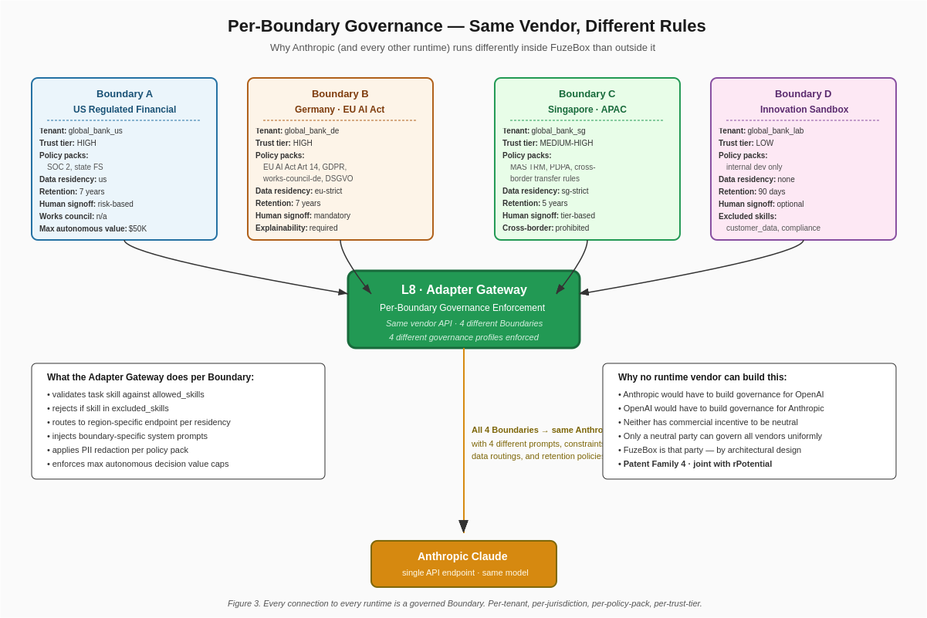
Figure 3 — Per-Boundary governance: same vendor, different rules
The Integration Abstraction Layer is the fourth irreplaceable architectural asset of the system. It is physically located at the Adapter Gateway (Layer 8). Every connection between FuzeBox and a runtime vendor is a governed Boundary. Every Boundary has its own configuration.
A single Fortune 500 enterprise running FuzeBox connects to all six vendors simultaneously — and typically connects to each vendor through multiple Boundaries within the same deployment. Figure 3 shows a realistic example: a global bank running four Boundaries to Anthropic in a single deployment.
Boundary A is the US Regulated Financial Boundary for the bank’s US operations. Trust tier HIGH. Active policy packs: SOC 2, the bank’s state financial services compliance profile. Data residency us-only. Retention 7 years. Human signoff is required for tasks above a risk threshold. Maximum autonomous decision value is set at $50,000 — any execution whose outcome value exceeds this threshold routes through human signoff regardless of the UEF’s raw score.
Boundary B is the Germany AI Act Boundary. Trust tier HIGH. Active policy packs: EU AI Act Article 14 high-risk, GDPR, DSGVO-specific variants, German works-council notification rules. Data residency eu-strict — the Anthropic endpoint used is the EU-resident deployment, and data never transits through non-EU infrastructure. Retention 7 years. Human signoff is mandatory for all strategic-skill tasks. Explainability is required on every execution.
Boundary C is the Singapore APAC Boundary. Trust tier MEDIUM-HIGH. Active policy packs: MAS Technology Risk Management, Singapore PDPA, APAC cross-border transfer rules (which in this Boundary are configured as prohibited — Singapore-originated data never leaves Singapore infrastructure). Data residency sg-strict. Retention 5 years. Cross-border transfer prohibited.
Boundary D is the Innovation Sandbox Boundary for the bank’s internal AI lab. Trust tier LOW — the lab is used for experimentation, not for customer-facing execution. Active policy packs: internal development only. Data residency none — the sandbox is explicitly isolated from production data. Retention 90 days. Human signoff optional. Excluded skills: customer_data, compliance, transaction_execution — the sandbox cannot touch any of these.
Same vendor — Anthropic — connected through the same Messages API. Four completely different governance configurations enforced by FuzeBox in the middle. The Anthropic runtime has no awareness of these configurations; they are invisible to Anthropic. The bank cannot enforce them in Anthropic directly because Anthropic does not ship per-customer jurisdictional governance. The enforcement happens at the Gateway, where it belongs.

What the Adapter Gateway Does Per Boundary
For every dispatch, the Adapter Gateway executes the following sequence:
Pre-dispatch validation. The Gateway loads the BoundaryConfig by boundary_id (which is derived from the task’s tenant_id and the selected runtime). It validates the task’s required Skill is in the Boundary’s allowed_skills list and not in excluded_skills — rejection is immediate with a structured HTTP 403 response explaining the policy violation. The Gateway applies any governance-profile transformations (PII redaction for GDPR Boundaries, compliance-specific data masking for Financial Services Boundaries, etc.). The Gateway enforces data residency by selecting the correct regional endpoint for the runtime.
Boundary-specific request shaping. The Gateway modifies the request per Boundary rules. For the Germany AI Act Boundary, the Anthropic system prompt is augmented with the Article 14 explainability instruction and the works-council notification requirement. For the US Regulated Financial Boundary, the prompt is augmented with SOC 2 audit context. For the Singapore Boundary, the prompt is augmented with PDPA compliance language. Same base prompt from the UEF, different final prompt sent to the runtime, enforced at the Boundary.
Instruction Runtime integration. Between request shaping and actual dispatch, the Gateway calls the Instruction Runtime to receive any live injections triggered by current signal state. This is the mechanism by which signal changes translate into prompt modifications on in-flight executions.
Dispatch to the vendor endpoint. The Gateway fires the actual request. For hybrid paths, multiple vendor dispatches run concurrently via errgroup. The Gateway manages timeouts, retries, and streaming response handling per vendor.
Post-dispatch validation. When the response returns, the Gateway validates it against Boundary requirements. If the Boundary requires evidence export, the Gateway extracts the evidence bundle from the response. If the Boundary requires human override availability, the Gateway confirms the response includes an override hook. If the Boundary’s data residency is violated (for example, a response trace indicates the request was routed through a non-authorized region), the Gateway logs a critical event and flags the execution for audit review.
Telemetry capture and forward. The Gateway captures the raw vendor trace and forwards to the Telemetry Normalizer.

Why This Cannot Be Built by a Runtime Vendor
Anthropic will not build per-customer Boundary controls that also work for OpenAI’s API. Doing so would require Anthropic to become the governance authority for its own competitor — an architecturally coherent but commercially impossible position. The same is true of OpenAI, Salesforce, Google, Cloudflare, and Uniphore in every combination. Every runtime vendor has commercial incentives aligned with driving their own consumption; no runtime vendor has commercial incentives aligned with operating as a neutral arbiter of its competitors.
FuzeBox has no other commercial reason to exist. That is precisely why FuzeBox can be trusted with the role. The neutrality is architectural, not aspirational.
This architecture is protected under Patent Family 4 of the FuzeBox portfolio, filed jointly with rPotential as co-inventor.

Part V — The Closed Loop

rPotential Integration as Architectural Peer
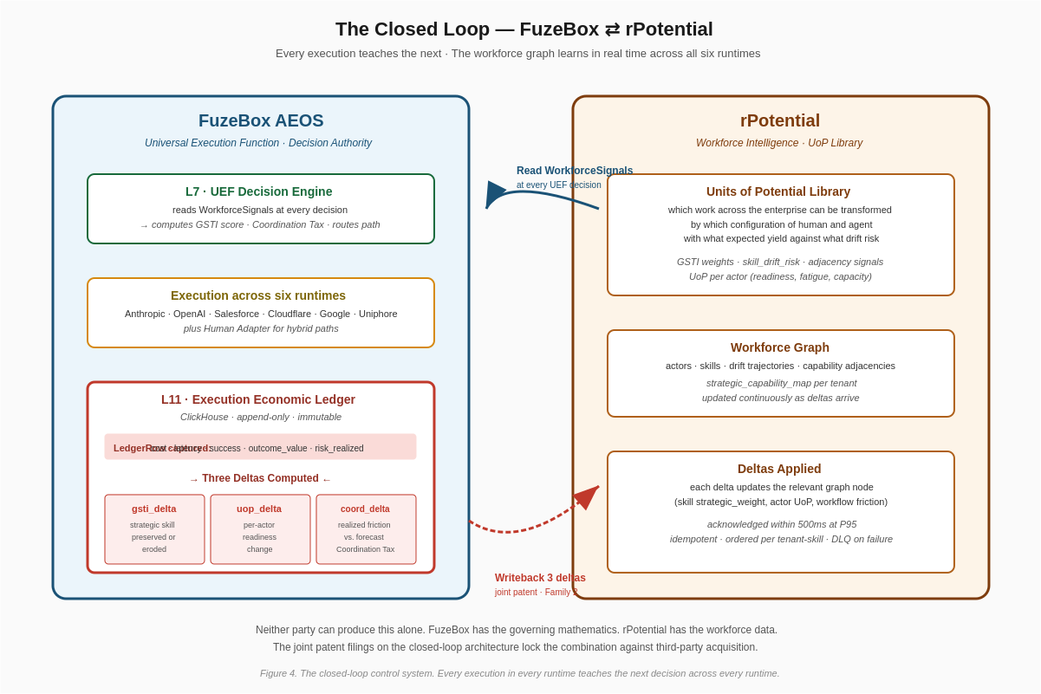
Figure 4 — The FuzeBox ⇄ rPotential closed loop
rPotential is not a data source. rPotential is an architectural peer. The integration is bidirectional, real-time, and continuous — and it is what transforms FuzeBox from a routing layer into a control system that learns at the scale of the entire enterprise.
On the read path, the Signal Bus (Layer 6) pulls the current WorkforceSignals from rPotential at the moment of every UEF decision. The signals contain the full state of the workforce relevant to the tenant and the task: GSTI per skill (strategic weight), skill_drift_risk per skill (erosion trajectory), UoP per actor (readiness, fatigue, capacity), Coordination Tax per workflow (organizational friction), and the strategic_capability_map that identifies which skills are mission-critical. The read latency is typically 50ms — the Signal Bus maintains a 5-minute TTL cache with live refresh on change events from rPotential.
On the write path, every execution produces a LedgerRow and three deltas. The gsti_delta captures how the execution changed the strategic weight of the Skill: positive for successful hybrid or human executions that preserved strategic capability, negative for pure-agent executions of high-drift-risk strategic skills. The uop_delta captures the per-actor readiness change: positive for successful strategic-skill exercise that sharpens the actor, negative for fatigue accumulation or for executions that bypassed the actor when they held the capability. The coordination_delta captures realized-versus-forecast organizational friction: negative when the hybrid or orchestration path ran cleaner than the Coordination Tax predicted, positive when it ran messier.
The deltas flow from the Ledger Service to the Signal Bus to rPotential’s UoP library via the joint-IP writeback contract. The contract specifies authentication via mutual TLS with tenant-scoped keys, idempotency keys on every delta so that network-level retries do not double-apply, per-tenant-per-skill Kafka partition ordering so that delta sequence is preserved, a sub-500ms P95 acknowledgment latency target, and dead-letter-queue handling for deltas that fail after retry — failed deltas surface on the enterprise tenant’s dashboard for operator attention.
rPotential applies the deltas to its workforce graph. Within seconds, the state that the next UEF decision reads is updated. A tenant executing 500 tasks per hour against its workforce will have the graph updating 1,500 times per hour with delta refinements. Over a quarter, the graph accumulates hundreds of thousands of delta observations — the workforce state becomes empirically grounded in actual execution outcomes rather than extrapolated from external signals.
This is the learning loop. Every execution teaches the next decision across every runtime. Anthropic’s agents run differently inside FuzeBox than they do outside it, because the prompts and constraints they receive are modulated by a workforce state that only FuzeBox can see and that only FuzeBox writes back to. The same is true for OpenAI, Salesforce, Cloudflare, Google, and Uniphore. The runtimes become governed executors; FuzeBox is the governor; rPotential is the ground truth against which the governance is measured.

Why Neither Party Can Be Acquired Away From the Other
The joint-IP structure on the closed-loop architecture is deliberate. Patent Family 2 — covering the real-time Execution Economic Ledger with closed-loop writeback — names both FuzeBox and rPotential as co-inventors. Patent Families 3, 4, and 5 are also joint filings. An acquirer attempting to absorb rPotential into a single runtime vendor would break the joint patent portfolio; the acquirer would need to license FuzeBox’s half of the IP, which FuzeBox has no commercial reason to provide to a vendor that is attempting to eliminate FuzeBox’s neutrality. An acquirer attempting to absorb FuzeBox into a single runtime vendor would similarly break the portfolio; rPotential’s position as a multi-vendor workforce intelligence provider depends on FuzeBox’s continued neutrality.
The partnership is structurally durable because the alternative — either party being acquired into a single runtime — is commercially and architecturally worse for both parties than the continued partnership. This is the design intent.

Part VI — The GSTI Scoring Model

Five Dimensions, Four Classifications
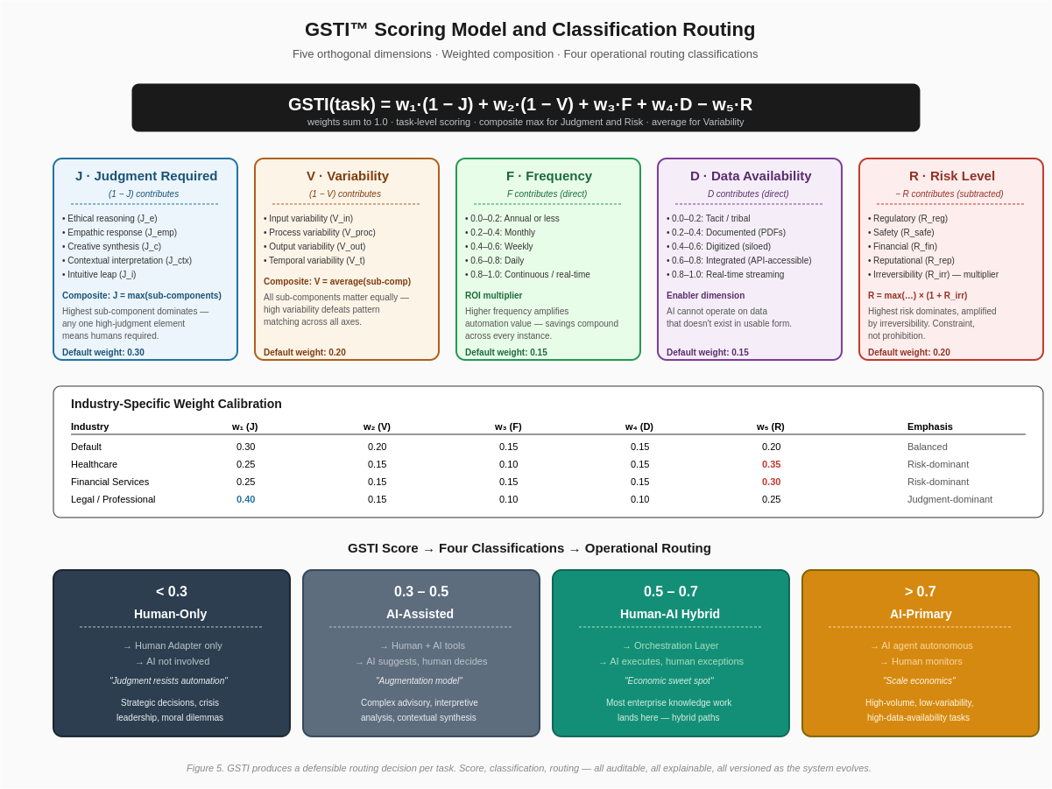
Figure 5 — GSTI scoring dimensions and classification routing
GSTI — the GenAI Suitability Transformation Index — is the algorithm that determines how AI participates in any given task. The formal specification is in the GSTI Deep Specification document; the summary in this section is sufficient for architectural and build context.
GSTI decomposes AI suitability into five orthogonal dimensions measured on a continuous zero-to-one scale:
Judgment Required (J). The degree to which successful task completion requires human cognitive capabilities that AI cannot reliably replicate. Judgment has five sub-components: ethical reasoning, empathic response, creative synthesis, contextual interpretation, intuitive leap. The composite uses maximum: J = max(J_e, J_emp, J_c, J_ctx, J_i). Any one high-judgment sub-component forces the composite high. A task with one ethical trade-off element is a judgment-heavy task even if every other sub-component is low. Higher J reduces GSTI because the task less suits AI.
Variability (V). The degree to which successful outcomes differ across instances. Variability has four sub-components: input variability, process variability, output variability, temporal variability. The composite uses average: V = (V_in + V_proc + V_out + V_t) / 4. All four matter equally because high variability defeats pattern-matching across every axis. Higher V reduces GSTI.
Frequency (F). How often the task occurs. This is an ROI multiplier — high-frequency tasks amplify automation value because savings compound. The measurement scale ranges from annual or less at the low end to continuous real-time at the high end. Higher F increases GSTI.
Data Availability (D). The degree to which the information required to execute the task is digitized, accessible, and structured. The scale ranges from tacit tribal knowledge at the low end to real-time streaming at the high end. This is an enabler dimension — AI cannot operate on data that doesn’t exist in usable form. Higher D increases GSTI.
Risk Level (R). The potential negative consequences of task failure or AI error. Risk has five sub-components: regulatory, safety, financial, reputational, and irreversibility. The composite: R = max(R_reg, R_safe, R_fin, R_rep) × (1 + R_irr). Highest risk category dominates, amplified by irreversibility. Risk is a constraint, not a prohibition — high-risk tasks can still use AI, but with mandatory human oversight. Higher R reduces GSTI.
The composition is: GSTI(task) = w₁·(1 − J) + w₂·(1 − V) + w₃·F + w₄·D − w₅·R where the weights sum to 1.0.
Default weights are 0.30 for J, 0.20 for V, 0.15 for F, 0.15 for D, 0.20 for R. Industry calibrations shift these: healthcare emphasizes risk at 0.35, legal and professional services emphasize judgment at 0.40, manufacturing emphasizes variability and frequency, retail emphasizes judgment against commoditized tasks. The weight table is stored per tenant and can be recalibrated quarterly based on empirical outcome tracking.

The Four Classifications and Routing Logic
GSTI scores map to four operational classifications, each routing to a distinct execution pattern:
Below 0.3 — Human-Only. The task is AI-unsuitable. The UEF routes exclusively to the Human Adapter. No AI runtime is invoked. This band captures strategic decisions, crisis leadership, genuine moral dilemmas, and high-judgment work where the AI contribution would be marginal and the downside unacceptable.
0.3 to 0.5 — AI-Assisted. The task has AI suitability but judgment or risk constrains autonomous execution. The UEF routes to a configuration where the AI provides suggestions and the human decides and acts. Typically this means dispatching the task to a runtime (Anthropic, OpenAI, or similar) with the output rendered to the human’s task queue for review before any action is taken. The AI is an assistant, not an executor.
0.5 to 0.7 — Human-AI Hybrid. The economic sweet spot of enterprise knowledge work. Most enterprise tasks at scale land in this band. The UEF routes to an orchestrated hybrid path: AI executes the bulk of the work, the Human Adapter handles exceptions, escalations, and strategic-signoff moments. This is where FuzeBox’s architecture delivers the most value — because the UEF is selecting specifically which AI runtime pairs best with which human actor for this specific task under the current workforce state.
Above 0.7 — AI-Primary. The task is well-suited to autonomous AI execution. The UEF routes to a pure-agent path on the runtime whose other scoring dimensions (runtime fit, economic value, capability fit) win. Human monitoring continues but is not in the execution loop. This band captures high-volume, low-variability, high-data-availability tasks such as classification, extraction, categorization, and scheduled reporting.
The thresholds are operationally tuned, not arbitrary. They align with distinct human-AI collaboration patterns that are empirically observable in enterprise transformations. The thresholds can be tenant-calibrated based on the tenant’s risk appetite and workforce composition.

What Makes GSTI Defensible
The formula could be copied. The defensibility is not in the equation. The defensibility is in the composite architecture: the orthogonal decomposition that prevents gaming, the sub-component granularity that enables precise diagnosis, the industry-calibrated weights derived from empirical transformation data, the composite functions (max for J and R, average for V) that reflect real-world dynamics, the routing-logic integration that makes scores actionable, and the temporal versioning that makes scores comparable across time as AI capabilities evolve.
Most importantly, the defensibility is in operational integration. GSTI as implemented in FuzeBox is not a spreadsheet exercise. It is a live signal computed thousands of times per minute against real workforce state streamed from rPotential and fed into real executions dispatched across six runtime vendors. Competitors cannot copy the system. They can at best copy the equation. This is Patent Family 1 of the FuzeBox portfolio.

Part VII — Service Topology

Eight Microservices, Shared Infrastructure, Plugin Adapters
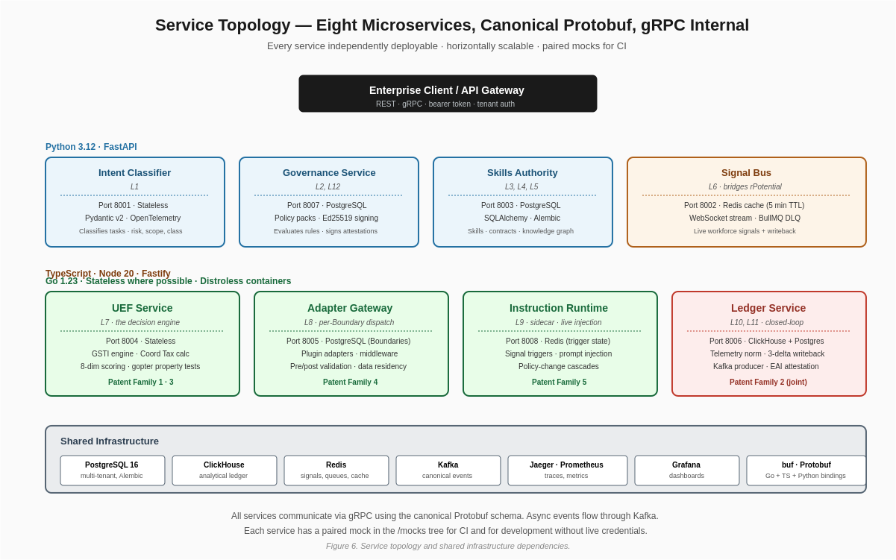
Figure 6 — Service topology and shared infrastructure
The twelve architectural layers are implemented across eight microservices. The services are heterogeneous in language and storage by design — Go for performance-critical stateless services, Python for governance and knowledge graph services that benefit from Python’s ecosystem, TypeScript for the Signal Bus because of its bridge role between a Node-heavy workforce intelligence ecosystem and FuzeBox’s Go backend.

The Eight Services
Intent Classifier (Python 3.12 + FastAPI, Port 8001, Stateless). Receives raw Task submissions, classifies them across task_type, complexity, risk_level, regulatory_class, and strategic_significance dimensions. Uses Pydantic v2 for schema validation. OpenTelemetry-instrumented with trace_id propagation via X-Trace-Id header. No persistent storage — each classification is computed from the submission payload. Horizontally scalable; scales against submission volume.
Governance Service (Python 3.12 + FastAPI, Port 8007, PostgreSQL). Loads policy packs, evaluates applicable rules against the Task + BoundaryConfig pair, produces a consolidated GovernanceRequirement, and produces signed evidence bundles at Layer 12. Policy packs live as versioned YAML documents in the service’s policy-packs/ directory. Signing uses Ed25519 with per-tenant keys managed via an HSM integration in production. Testcontainers-based integration tests cover the full policy-pack evaluation matrix.
Skills Authority (Python 3.12 + FastAPI, Port 8003, PostgreSQL). Maintains the canonical registry of Skills, Agent Contracts, Actors, and the enterprise knowledge graph. SQLAlchemy with Alembic migrations. Seeded with a domain-specific skills catalog per tenant during onboarding. Performance history per Skill × ExecutionPath is updated continuously from Ledger writebacks. Horizontally scalable with read replicas; the write path (performance updates) is serialized per skill-path key.
Signal Bus (TypeScript + Node 20 + Fastify, Port 8002, Redis). The bridge to rPotential. Maintains a 5-minute TTL cache of WorkforceSignals per tenant in Redis. On writeback POST requests from the Ledger, applies deltas to the cache and forwards to rPotential via a BullMQ-backed queue with 3-retry exponential backoff and dead-letter-queue on persistent failure. WebSocket stream for clients subscribing to live signal changes (threshold 0.02 material-change filter). This service is TypeScript because it bridges between Node-heavy workforce intelligence ecosystems and FuzeBox’s Go core.
UEF Service (Go 1.23, Port 8004, Stateless). The decision engine. Implements the eight-dimensional scoring composition with each dimension in its own file under internal/scoring/. Property-based tests via gopter enforce invariants. The GSTI engine and Coordination Tax calculator are embedded (either ported directly to Go from the existing Python implementations or invoked via gRPC from a dedicated sidecar, per the engineering lead’s judgment — both approaches are architecturally acceptable). Zap structured logging. Distroless container image under 25MB. Horizontally scalable against decision volume.
Adapter Gateway (Go 1.23, Port 8005, PostgreSQL for Boundaries). The runtime dispatch hub. BoundaryConfig storage in PostgreSQL with per-tenant and per-vendor indexing. Plugin architecture — each adapter is a Go package imported under a common interface. Pre-dispatch and post-dispatch middleware layers for validation. Cost-estimation middleware for dispatch decisions. Horizontally scalable.
Instruction Runtime (Go 1.23, Port 8008, Redis). Sidecar service called by the Adapter Gateway between decision and dispatch. Trigger registry in Redis with per-tenant configuration. Signal-subscription to the Signal Bus WebSocket stream. When triggers fire, produces injection payloads (revised system prompts, modified function schemas, updated tool scopes, data-access changes) that the Adapter Gateway applies to the in-flight request. Trigger evaluation completes in under 50ms to maintain the end-to-end latency budget.
Ledger Service (Go 1.23 + ClickHouse, Port 8006, ClickHouse + PostgreSQL). Append-only telemetry normalization and economic ledger. ClickHouse as the primary analytical store for historical LedgerRows. PostgreSQL mirror for the most recent 7 days for transactional integrity on delta writebacks. Kafka producer for canonical events. Computes the seven derived metrics (UCS, SY, SER, EROI, SDD, HPI, HLR) continuously. Produces the Enterprise Autonomy Index quarterly attestation with joint FuzeBox and rPotential Ed25519 signatures.

Shared Infrastructure
PostgreSQL 16 serves three services (Governance, Skills Authority, Adapter Gateway) with separate databases per service and schema-per-tenant for multi-tenancy. Alembic for Python services; sqlc for Go services.
ClickHouse is the analytical store for the Ledger. MergeTree engine with per-tenant and per-skill partitioning. Retention policies configured per tenant per policy-pack requirements (7 years for SOC 2, 7 years for EU AI Act Article 14, 5 years for Singapore PDPA).
Redis serves the Signal Bus cache, the Instruction Runtime trigger state, and the Adapter Gateway’s per-Boundary policy-pack cache. Cluster-mode in production.
Kafka carries canonical events from the Telemetry Normalizer to the Ledger. Per-tenant partition keys to preserve ordering. Schema registry to version the CanonicalEvent message format.
Jaeger + Prometheus + Grafana provide distributed tracing, metrics, and dashboards. OpenTelemetry-Collector aggregates signals. Pre-built Grafana dashboards at /observability/ cover the control plane’s end-to-end performance, per-service health, per-runtime dispatch rates and latencies, Ledger writeback latencies, and Enterprise Autonomy Index trend lines.
buf manages the canonical Protobuf schema. buf.gen.yaml configures Go, TypeScript, and Python binding generation. Generated bindings are committed to the repository for reproducibility.

Deployment Model
The production deployment runs on Kubernetes. Each service is a Kubernetes Deployment with horizontal pod autoscaling tied to service-specific metrics (UEF scales against decision request volume; Adapter Gateway scales against dispatch volume; Ledger scales against canonical event ingestion rate). Stateful services (the ClickHouse and PostgreSQL clusters) run as StatefulSets with persistent volume claims. Multi-region deployment is supported for tenants requiring regional data residency; the regional deployments share the schema but segregate data per the Boundary configurations.
For development and for the One-Week Demonstration, a docker-compose deployment on a single VM is the supported topology. The docker-compose stand-up time is under 3 minutes on a fresh clone with credentials provisioned.

Part VIII — Canonical Data Schema

Protobuf Definitions
The canonical schema is the contract between every service. It lives in shared/schema/ as .proto files. buf generates Go, Python, and TypeScript bindings. The generated code is committed to the repository.
The core message types:
Task (Layer 1 intent capture). Fields: task_id, task_type, description, complexity, risk_level, strategic_significance, regulatory_class, jurisdiction, latency_budget_ms, cost_budget_usd, explainability_required, human_signoff_required, workforce_impact_scope, tenant_id, boundary_id, submitted_at, metadata map.
Skill (Layer 3 registry entry). Fields: skill_id, name, allowed_paths (repeated ExecutionPath), required_tools, governance_tags, strategic_weight, performance (map ExecutionPath → PathPerformance), drift_sensitivity, adjacency_skills (map skill_id → coupling strength).
ExecutionPath (enum). Values: HUMAN, ANTHROPIC, OPENAI, SALESFORCE, CLOUDFLARE, GOOGLE, UNIPHORE, plus every human-hybrid combination (HYBRID_ANTHROPIC_HUMAN, HYBRID_OPENAI_HUMAN, HYBRID_SALESFORCE_HUMAN, HYBRID_CLOUDFLARE_HUMAN, HYBRID_GOOGLE_HUMAN, HYBRID_UNIPHORE_HUMAN), plus multi-vendor chains (HYBRID_MULTI_VENDOR, HYBRID_MULTI_VENDOR_HUMAN).
Actor (human or agent executor). Fields: actor_id, actor_type, provider, capabilities, availability, fatigue, capacity, certifications, tenant_id, workforce_segment, jurisdiction, cost_per_hour_usd.
WorkforceSignals (Layer 6 rPotential payload). Fields: tenant_id, gsti (map skill_id → float), skill_drift_risk (map skill_id → float), uop_by_actor (map actor_id → ActorUOP), coordination_tax (map workflow_id → float), strategic_capability_map (map skill_id → criticality tier), snapshot_at.
ActorUOP (per-actor readiness). Fields: readiness, fatigue, capacity, recent_execution_count, time_since_last_strategic_skill, drift_exposure.
BoundaryConfig (Layer 8 per-vendor-per-tenant rule set). Fields: boundary_id, tenant_id, vendor, jurisdiction, allowed_skills, excluded_skills, agent_contract_id, governance_profile, trust_tier, policy_packs, coordination_tax_profile, writeback_destinations, data_residency, maximum_autonomous_decision_value.
GovernanceRequirement (derived at Layer 2). Fields: audit_log_required, trace_retention_days, human_override_available, human_signoff_required, policy_packs, data_residency_required, explainability_required, evidence_export_required, workforce_impact_threshold, cross_border_transfer_allowed.
ScoredPath (Layer 7 output). Fields: path, capability_fit, gsti_value, uop_value, coordination_tax, governance_score, runtime_fit, economic_value, risk_penalty, workforce_preservation_score, total, selected_actor_id, justification (structured), alternate_paths (repeated ScoredPath).
LedgerRow (Layer 11 append-only record). Fields: execution_id, task_id, skill_id, selected_path, actor_ids, execution_cost_usd, latency_ms, success, success_probability_predicted, outcome_value_usd, risk_penalty, coordination_tax_realized, gsti_delta, uop_delta, coordination_delta, workforce_preservation_outcome, audit_record_id, timestamp, tenant_id, boundary_id, jurisdiction, policy_packs_applied.
CanonicalEvent (Layer 10 normalized trace). Fields: event_id, execution_id, vendor, type (enum: TOOL_CALL, LLM_CALL, HANDOFF, APPROVAL, HUMAN_IN_LOOP_ACCEPT, HUMAN_IN_LOOP_REJECT, ERROR, ESCALATION), timestamp, duration, cost_usd, raw_payload, metadata.

Part IX — Observability, Security, and Operational Readiness

Observability
Every service emits OpenTelemetry traces, Prometheus metrics, and structured JSON logs with trace_id propagation. The OTel Collector aggregates signals and exports to Jaeger (traces), Prometheus (metrics), and Loki (logs). Grafana hosts the pre-built dashboards.
Dashboards include: control-plane end-to-end latency percentiles, per-service health and error rates, per-runtime dispatch volume and latency distributions, Ledger writeback latency to rPotential, Coordination Tax trend lines per tenant, GSTI score distribution by Skill, HPI (Human Preservation Index) trend lines, EAI (Enterprise Autonomy Index) attestation generation, and signal-freshness for rPotential integration.

Security
Authentication and authorization. All inter-service communication uses mutual TLS. All external APIs require bearer tokens per tenant; tokens are scoped to specific Boundaries and specific operations. Per-tenant OAuth2 integration is supported for tenants whose IT organization mandates SSO.
Secrets management. All runtime vendor credentials, signing keys, and database credentials are loaded from a secret store (HashiCorp Vault or equivalent). No secrets are committed to the repository. CI/CD pipelines include trufflehog scans to prevent accidental commits.
Data isolation. Per-tenant data isolation is enforced at the storage layer (schema-per-tenant in PostgreSQL, per-tenant partitioning in ClickHouse) and at the application layer (tenant_id is a required field on every message and is validated at every service boundary).
Audit trails. Every significant operation — every decision, every dispatch, every writeback, every Instruction Runtime injection, every Boundary rule change, every policy pack update — is recorded in the audit log with cryptographic timestamping. The audit log is immutable and retention-policy-governed.
Dependency scanning. CI includes Trivy scans on every build. Builds fail on HIGH or CRITICAL vulnerabilities. Dependency updates are managed via Dependabot.

Production Operational Readiness
High availability. All services run with at least 3 replicas in production. Stateful services (PostgreSQL, ClickHouse, Redis, Kafka) run in clustered configurations with replication. Service-level SLOs are 99.9% availability on the control-plane path, 99.95% on the read path from the Signal Bus.
Disaster recovery. RPO 15 minutes, RTO 4 hours. PostgreSQL WAL archival to object storage with point-in-time recovery. ClickHouse zero-copy snapshots. Redis AOF persistence with regular snapshots. Kafka replicated across availability zones.
Capacity planning. Horizontal autoscaling targets a P95 latency budget of 2 seconds for fast-path decisions and 10 seconds for complex multi-runtime hybrid executions. Autoscaling is triggered on CPU, memory, and per-service custom metrics (UEF decisions/sec, Adapter Gateway dispatches/sec, Ledger ingestion rate).
Incident response. On-call rotation with 15-minute response SLA for P0 incidents. Runbooks per service. Chaos engineering exercises quarterly.

Part X — The Five Patent Families
The architecture described in this document is protected under five patent families, four of which are joint filings with rPotential as co-inventor.
Patent Family 1 covers the GSTI algorithm and Coordination Tax computation. Sole FuzeBox filing. Claims: the orthogonal five-dimensional decomposition with max-based and average-based composite functions; the industry-calibrated weight model; the temporal versioning scheme; the routing-logic integration from score to classification to dispatch.
Patent Family 2 covers the real-time Execution Economic Ledger with closed-loop writeback. Joint FuzeBox and rPotential filing. Claims: the three-delta computation from the canonical LedgerRow; the writeback contract with idempotency and ordering guarantees; the seven derived metrics; the Enterprise Autonomy Index attestation format.
Patent Family 3 covers the Skills Authority with dynamic capability gating. Joint filing. Claims: the skill-as-executable-object model with allowed_paths that shift in real time; the per-agent Contract schema; the performance-history-weighted capability fit scoring; the automatic corrective-routing mechanism when strategic skills drift.
Patent Family 4 covers the Integration Abstraction Layer with per-Boundary governance enforcement. Joint filing. Claims: the Boundary configuration schema supporting multiple simultaneous Boundaries per vendor per tenant; the pre-dispatch and post-dispatch middleware pattern; the canonical-to-vendor-native translation with boundary-specific transformations; the per-Boundary policy-pack enforcement.
Patent Family 5 covers the Dynamic Instruction Runtime. Joint filing. Claims: the signal-to-injection trigger mechanism; the vendor-specific injection patterns across all six runtimes; the audit capture of every injection with justification.
Together the five families protect the full architecture against replication. A competitor can build individual components; no competitor can build the combination without infringement. The joint-filing structure locks the FuzeBox-rPotential combination against third-party acquisition as described in Part V of this document.

Part XI — The Build Plan

From Seven-Day Demo to Production
The architecture is delivered in two phases. The One-Week Demonstration Specification (companion document) describes the first phase — a seven-day build that stands up a runnable, end-to-end proof of every architectural element with all six runtime vendor integrations live, the rPotential closed loop operating, and four demonstration scenarios running cleanly. The demo is sufficient for partnership conversations with every runtime vendor, for strategic conversations with rPotential leadership, for board-level demonstrations, and for engineering review.
Production readiness is a twelve-week engagement. The production build extends the demo codebase — nothing is discarded — with ClickHouse replacing SQLite, Kafka replacing the in-process event bus, Kubernetes replacing docker-compose, multi-region deployment replacing single-region, the full 14-jurisdiction policy pack library replacing the demo’s 3 packs, real enterprise workforce-management integration replacing the demo’s seeded data, mutual TLS replacing basic bearer tokens, and production observability at enterprise scale replacing the demo’s local stack.
The production engagement is structured as a 6-milestone fixed-price contract with Trigent or Trigma (or any other qualified engineering partner) at $85,000–$115,000 depending on team composition. The milestones align to the architectural zones and deliverable phases described in this document. Detailed scope, milestone definitions, and acceptance criteria are in the Production Build Specification (separate document).

What’s Built Now
The GSTI engine is implemented in Python and producing scores on real enterprise processes. The Coordination Tax calculator is implemented and consuming real event streams. The five patent families are in filing. The rPotential integration architecture is specified jointly. The six runtime vendor integration surfaces are all accessible with test credentials. The demo codebase scaffolding exists. The full canonical schema is specified.

What’s Coming
The seven-day demonstration build. The twelve-week production build. The first wave of Fortune 500 tenant onboardings. The partnership commercial motions with Anthropic, OpenAI, Salesforce, Cloudflare, Google, and Uniphore enterprise partnership teams. The Adecco Group channel launch via rPotential. The patent portfolio prosecutions. The Enterprise Autonomy Index as a board-level SKU.
The architecture is ready. The commercial motions are in motion. The engineering partners are lined up. What remains is disciplined execution against the specifications described in this document and its companions.

Appendix — Documents in This Series
FuzeBox AEOS White Paper — the strategic and commercial positioning of the category, the four board-level questions the system answers, and the logic of why the architecture is irreplaceable. For executive audiences, strategic partners, and prospective customers.
FuzeBox AEOS One-Week Demonstration Specification — the seven-day build plan, the four demonstration scenarios, the repository structure, the day-by-day milestones, and the commercial structure for the demo build. For engineering leadership at build partners and for FuzeBox’s own engineering team.
FuzeBox AEOS Full Architecture Document — this document. The technical specification with visual system designs, canonical schema, service topology, observability and security model. For engineering partners, prospective integration teams, and technical evaluation audiences.
GSTI Deep Specification — the canonical reference for the GSTI algorithm, the five dimensions, the industry calibrations, the classification thresholds, and the CAITO certification protocol. Referenced by this document and embedded in the UEF implementation.
Production Build Specification — the 12-week engagement scope for the production system beyond the demo. Milestone structure, acceptance criteria, commercial terms.
Patent Portfolio Summary — the five patent families in filing, the joint-IP structure with rPotential, and the defensive posture against third-party acquisition.

End of Full Architecture Document.
FuzeBox.AI · Confidential · April 2026

